**LINQ**

Two files exist, Students.json and Transactions.xml. Download both files and drag them into a C# Console Application. Below in Appendix A, there exist two classes which map to the files which you can copy. Use them as required.

Caoimhe done this section

**Section 1 – 35%**

Using the Json file and write a LINQ query which will;

1. List all students in ascending order of last name.
2. List all students whose last name begins with a W.
3. Group all students by gender and list only their first name, last name and gender to screen.
4. List all students in descending order of Student id.
5. List all students whose gender is male and last name is Kinnard.

**Section 2 – 40%**

Open and load the XML file and write a LINQ query which will;

1. List all transactions order by Credit Card Number.  
   Text

   Description automatically generatedText

   Description automatically generated
2. List all transactions whose total_ex_vat is greater than €2000 and the number of items less than 3.  
   Text

   Description automatically generated
3. List all transactions with their total amount due – Total_EX_VAT + VAT . This query should create an anonymous object with just two fields of Transaction ID and Total_Amt_Due.  
   Text

   Description automatically generatedA screenshot of a computer

   Description automatically generated with medium confidence
4. Create a new XML file called Transactions2.xml, with a comment of “Updated of Total Amt Due”, new Root element called “Stock”, write all order elements to file with the added child element of Total_Amt_Due.   
   Text

   Description automatically generated  
   Text

   Description automatically generated

**Section 3 – 25%**

Using both files, write LINQ queries (using either method) which will;

1. List only students who have Transactions. Include only TransactionID and the first_name, last_name of the student.  
     
   *This syntax seems correct and variable names match, however, the code snippet has an issue that I couldn't solve.*  
     
   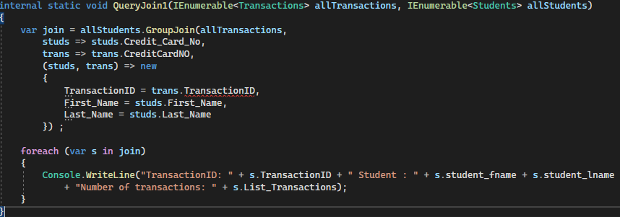

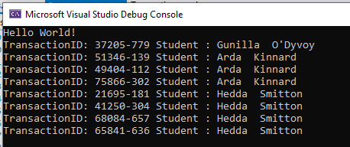

1. List **all** students and their total number of transactions made.

–

Appendix A

public class Transactions

{

public string Transaction_ID { get; set; }

public string Credit_Card_no { get; set; }

float VAT { get; set; }

float Total_Ex_VAT { get; set; }

int Number_of_items { get; set; }

}

public class Students

{

[JsonPropertyName("Student_id")]

public int Student_ID { get; set; }

[JsonPropertyName("first_name")]

public string First_Name { get; set; }

[JsonPropertyName("last_name")]

public string Last_Name { get; set; }

[JsonPropertyName("email")]

public string Email { get; set; }

[JsonPropertyName("gender")]

public string Gender { get; set; }

[JsonPropertyName("Credit_Card_No")]

public string Credit_Card_No { get; set; }

}